RiskLab - Architecture Diagram and API documentation

RiskLab - Architecture Diagram and API documentation

This document describes the Architecture of RiskLab application used for handling the Risk Rejects published by Passport. Overview of APIs created and used in this application is also included in this document

RiskLab - Architecture Diagram

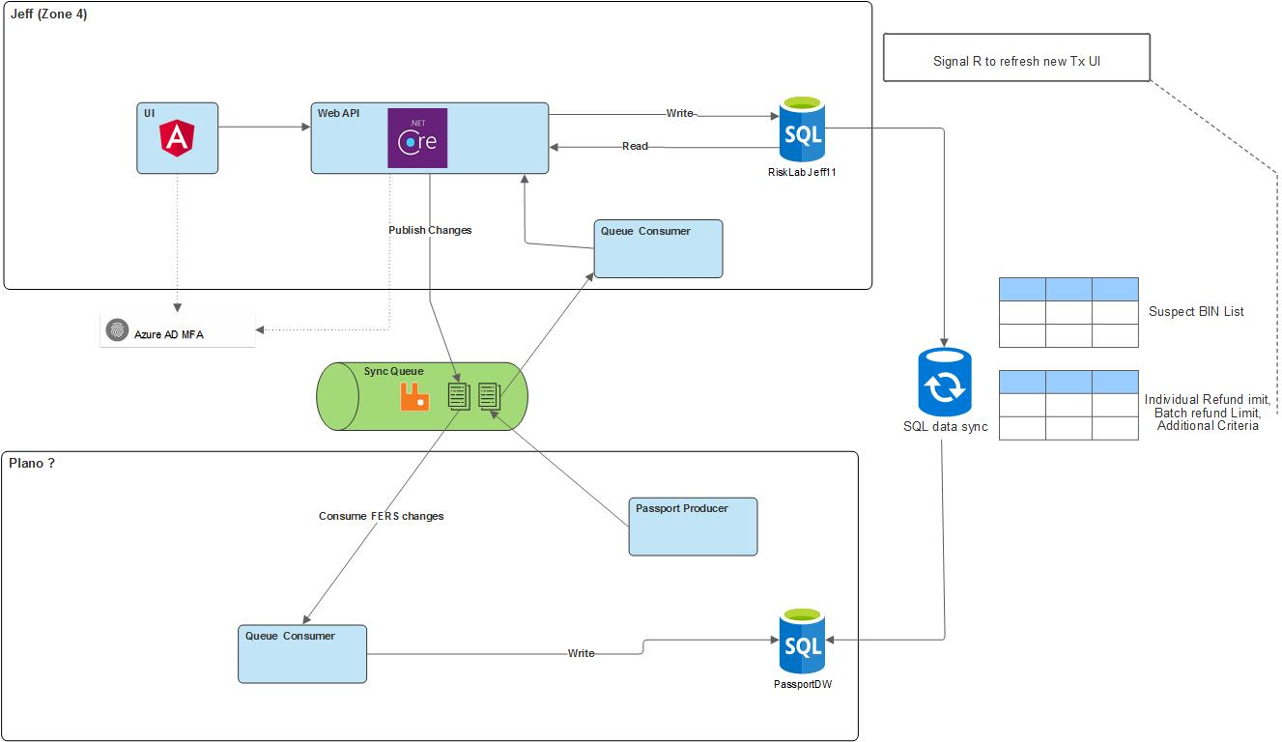

RiskLab - API Documentation
RiskLab UI makes use of following APIs to populate data and various user actions
- IndividualTransactionsController
This controller is created for operations related to individual transaction rejects. This includes following end points
  - GET - IndividualTransactions
Endpoint Details:
URL | https://<base-url>/api/IndividualTransactions
Method | GET
Request | Param:  status=’%newStatus%’  newStatus can be any of-  Queued  Released  Deleted
Response | Status:  200 Ok  Return type - application/json  Body:  {  “IndividualTxnId”: 123  "MessageId": "msgId",  "TxnUuid": 123456789,  "TxnDetailId": 123456,  "MerchantNumber": "123456789",  "MerchantName": "Merchant Name",  "LegalName": "Legal Name",  "ChainOID": "123",  "MCC": "1234",  "Amount": 100.5,  "CardNumberMask": "1234-5678-****-****",  "TxnDate": "2022-03-23T18:25:43.511Z",  "FraudRejectReasonCode": [  "Transaction threshold exceeded",  "Fraudulent BIN",  "Batch threshold exceeded"  ],  "OriginalBatchNumber": "12345678",  "AuthCode": "1234",  "ExpDate": "2022-06-23T18:25:43.511Z",  "TxnTypeDescription": "Sales",  "BatchCloseDate": "2022-03-23T18:25:43.511Z",  "SubmitterIDDescription": "Exchange",  “Status” : “new”  “DaysToAct”: 20  }
  - POST - IndividualTransactions
URL | https://<base-url>/api/IndividualTransactions
Method | POST
Request | Body:  {  "transactions": [  {  "transactionId": 45,  "newStatus": "queued"  },  {  "transactionId": 5,  "newStatus": "release"  }  ],  "loginName": "loginName"  }
Response | Status:  200 Ok  Return type - application/json  Body:  [  {  "transactionId": 45,  "updateStatus": "Failed",  "statusCode": “404”  },  {  "transactionId": 5,  "updateStatus": "Success",  "statusCode": "200"  }  ]

